# Polygon Extraction from PNG Image in QGIS

This document demonstrates the process of extracting polygons from a PNG image using a Python script in QGIS. The input image is processed to detect and extract areas of a specific color, which are then converted to polygons and loaded into QGIS.

## Input Image

The following image was used as the input for polygon extraction:

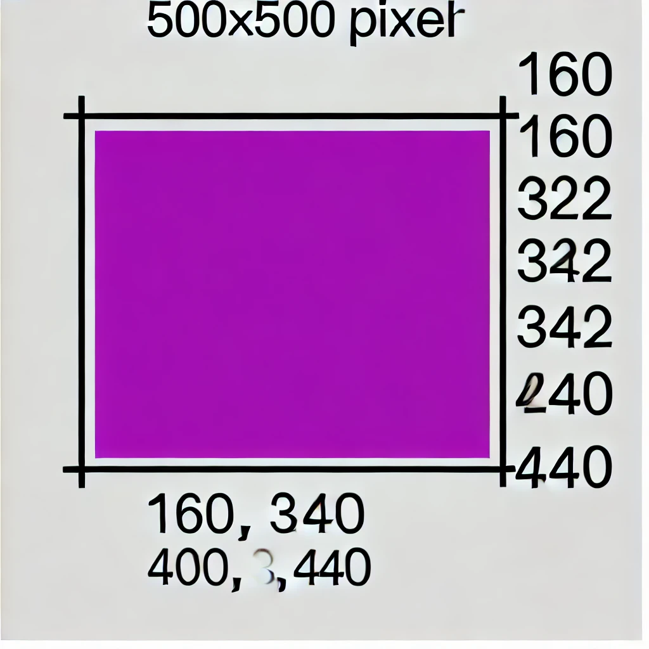

Figure 1: Original image used for polygon extraction.

## Extracted Polygon in QGIS

The extracted polygon was successfully loaded into QGIS. Below is a screenshot of the result:

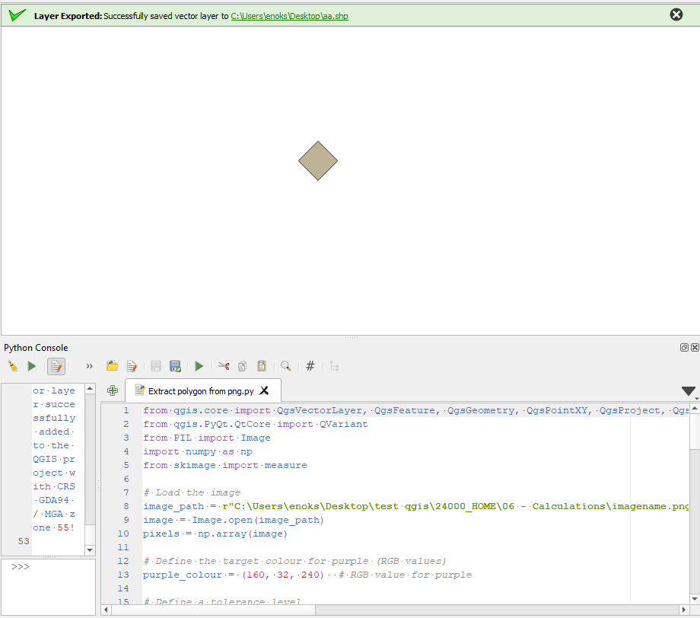

Figure 2: Extracted polygon displayed in QGIS.